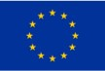

**Report AquaSPICE**

***Case study at Dow Terneuzen***

***Part I: Cooling tower blowdown treatment***

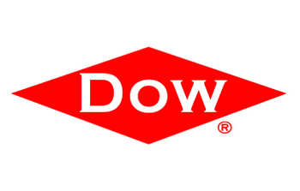

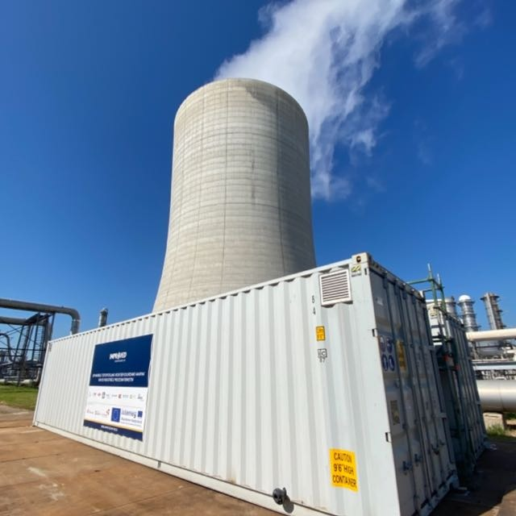

**The Improved containers on site at Dow Terneuzen**

|  |
| --- |
| **Case study at Dow Terneuzen Part 1: test period July - November 2021** |
| **Main authors**  Ivaylo Hitsov, PhD, *UGent* (Preparation of the report, main operator)  Lies Hamelink, BSc., *HZ University of applied sciences (Preparation of the report, operator)* |
| **Correctors**  Nicolaas Van Belzen, BSc., Dow  Niels Groot, PhD, Dow  Carmen Huth, MSc, Dow  David Moed, PhD, *Evides* *Industriewater*  Lisa Wyseure, MSc, *Evides* *Industriewater* |
| **Others involved**  Andrea De Las Heras Garcia, operational support and project organization  Nicolaas Van Belzen, BSc., *Dow*. Project supervision and support. Analytical data  Cornelis Groot, PhD, *Dow* – Project supervision  Kathleen Verhoeyen, *Dow* – Measurement preparation  Hans Cappon, PhD, *HZ* (RO data normalization Matlab code)  *Dow* control room operators P&U, shift supervisors and engineers |

Contents

1. Abstract 6

2. Introduction 6

2.1 Problem Statement of the Dow Terneuzen case 6

2.2 Goal 6

3. Technologies of interest 8

3.1 Reverse osmosis 8

3.2 Granular Activated Carbon (GAC) 9

3.3 Ultrafiltration 9

4. Materials and Methods 10

4.1 Reverse osmosis 10

4.2 Granular activated carbon 10

4.3 Ultrafiltration 10

5. Results and Discussion 11

5.1 Time schedule 11

5.2 Feed water quality 11

5.3 Performance of RO train 13

Performance of GAC 13

Performance of UF 15

Performance of RO 17

Quality obtained by RO treatment 19

5.4 Performance of the EDR treatment 21

5.5 Chemical usage 22

GAC 22

UF 22

RO 22

EDR 23

During the trials of EDR at REDstack, no chemicals were used. 23

5.6 Integration of the treatment train at the Dow plant 23

Current situation 23

Integrating GAC-UF-RO treatment 24

Integrating EDR treatment 24

Studying per-ion performance of the treatment options 25

1. Conclusions 26

2. Acknowledgments 26

3. References 26

List of abbreviations 28

Appendices 29

A.1 Membrane autopsy of the RO fouling after the UF-RO tests 29

A.4 Equations used in the RO normalization 33

# Abstract

During the first part of the Dow Terneuzen trials of AquaSPICE, the IMPROVED containers were deployed and the cooling tower blowdown produced by the largest cooling tower on site was treated in view of reuse as make up water. Granular activated carbon (GAC), ultrafiltration (UF) and reverse osmosis (RO) were tested in two combinations - GAC-UF-RO and UF-RO. The GAC-UF-RO worked very stable at 70 % overall system recovery and produced water with extremely good quality in terms of organics (< 50 ppb TOC) and acceptable quality in terms of conductivity (<120 µS/cm). The UF-RO on the other hand was not stable at all, proving the necessity of having the GAC as pretreatment in order to protect the RO.

Electrodialysis reversal (EDR) was also tested in these trials, but the technology was not stable inside the IMPROVED containers. Sample was provided to the manufacturer of the EDR where the tests showed that EDR was stable and obtained 50 % recovery with final quality of a single stage of 1.8 mS/cm, but only marginal level of organics removal resulting in TOC of around 35 ppm.

# Introduction

Fresh water is of major importance for the chemical industry, as it is used in all many chemical processes as an ingredient, for cooling and for steam production. However, the continuous supply becomes more uncertain nowadays, as ground and surface water are depleting or getting less usable due to lower quality (i.e. becoming too saline). The reuse and production of industrial process water as well as turning to alternative sources of water delivers a sustainable solution to this problem. In this research the potential of new technologies for reuse of cooling tower blowdown is investigated within the AquaSPICE project.

## Problem Statement of the Dow Terneuzen case

The I-Parc Dow Terneuzen is under severe water stress as it is located in a coastal area with very limited availability of fresh water. With the AquaSPICE project, the I-Parc Dow Terneuzen strives to reduce its fresh water intake intensity by (a) enhancing the internal recycle of various process water streams – these comprise (but are not limited to) cooling tower blowdown (CTBD) and dilution steam blowdown (DSBD) streams, and (b) creating a next level of site water management by using smart monitoring, algorithms and control on raw water, discharge and recycle streams.

The I-Parc Dow Terneuzen has a long history in water reuse and recycling. In the next step the fresh water use per unit of product can only be decreased by further closing the internal water loop, decreasing discharges and reclaiming non-polluted rainwater.

Currently the flows of return steam condensates and demineralized water are directed based on operator decisions using measurements of temperature, conductivity and TOC. A water cyber-physical system (WaterCPS) of the Dow Terneuzen case should be created to act as a decision support for the Dow operators. A sensor network of these and likely additional parameters should be created in real time and a model should be constructed to facilitate decisions-making in the most economical and ecological way.

## Goal

The Terneuzen I-Park has 16 evaporative towers with varying size and operation mode (make-up quality, treatment program, blowdown discharge). Four of these comprise 90 % of the total cooling capacity and will be addressed in this project (total blowdown rate of 1.5 million m³/y). Approximately 50 % of the blowdown is directly discharged to the river, the rest is sent to Dow’s WWTP. The objective is to treat CTBD such, that it can directly be reused as cooling tower make-up.

The IMPROVED pilots were built within the IMPROVED project funded by Interreg Flanders-Netherlands. In the AquaSPICE project, the pilots were placed nearby the biggest cooling tower at Dow where the experiments were conducted with online water supplied by the LHC-3 cooling tower. The IMPROVED pilots are housed in two 40 ft sea shipping containers and contain 7 water treatment skids that can be rearranged in different configurations. They can treat up to 2 streams at the same time with nominal flow rate of 250 l/h each. The available water treatment skids are Reverse Osmosis (RO), Ultrafiltration (UF), Ion Exchange (IEX), Granular Activated Carbon (GAC), Membrane distillation (MD), Electrodialysis with reversal possibility (EDR), Advanced Oxidation Processes (AOP) and recently coagulation and flocculation including lamella settler.

This report focuses only on the cooling tower blowdown treatment. In a continuous mode the cooling tower blowdown was directly taken from the single-largest cooling tower on the Terneuzen site that is a hybrid natural and forced draft cooling tower. The cooling tower is fed with a mixture of treated industrial (Dow’s) wastewater (‘BIOX’ or ‘Biox effluent’) and surface water coming from the Belgian polders. The cooling tower is disinfected to prevent legionella growth twice per day. Sodium hypochlorite is used for one hour in which the cooling tower blowdown valve is closed and the free chlorine concentration is between 1 and 5 ppm. The flows of this cooling tower are represented Figure 1:

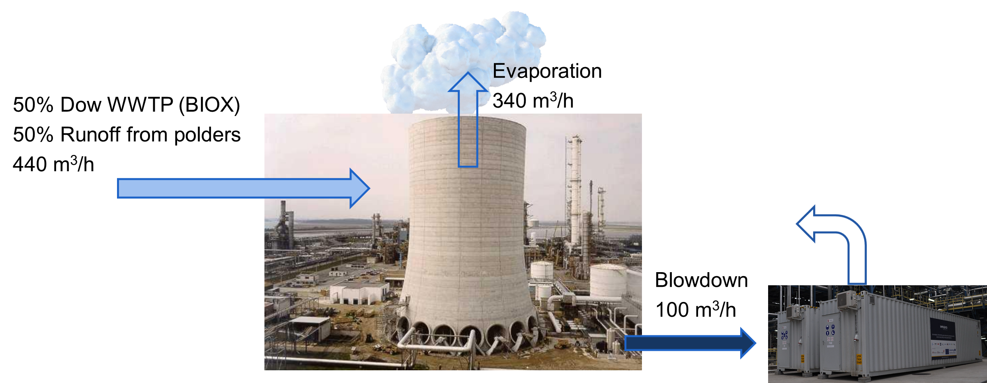

Figure 1 Schematic representation of the cooling tower blowdown treatment situation at Dow Terneuzen

The cooling tower is dosed with certain blend of corrosion inhibitors, one of which is the 4-5H-1H-methyl benzotriazole. This component is known from previous pilot-scale experiment within the E4Water project to irreversibly foul NF membranes. The exact mechanism of membrane fouling is unknown, but it is speculated that certain metals from the water matrix form a stable complex with the 5H-methyl-benzotriazole which then coats the membrane. While this layer was confirmed via microscopy to be very thin, it was very resilient to conventional membrane cleaning methods and severely impacted the membrane permeability.

In the leg 1 tests, the cooling tower blowdown was treated with reverse osmosis as well as electrodialysis in order to study the feasibility of reusing the treated water as cooling tower makeup.

The main technological train that was tested in the IMPROVED containers for the CTBD test was GAC-UF-RO. It should be noted that the GAC was operated in absorption mode for about 1 month after which it was exhausted and acted as a carrier for biological community and pre-filtration. Besides, the GAC removed the free chlorine from bleach addition that was done twice per day to prevent legionella growth. Finally, the GAC also worked as a mechanical filtration removing about 50% of the incoming turbidity. When the pressure drop of the GAC increased due to excess biomass and filtered material it was backwashed with frequency of 1-2 times per week and sent to waste. The UF removed the remaining turbidity and RO removed the remaining organics (TOC) and ions. After the pretreatment of GAC and UF, the reverse osmosis is used to desalinate the stream and remove most of the remaining organics.

Electrodialysis Reversal (EDR) was also piloted on the CTBD stream, but due to time limitations and certain operational problems, the EDR tests were done at the piloting facility of the stack manufacturer REDStack at Afsluitdijk the Netherlands.

# Technologies of interest

## Reverse osmosis

In RO, a pressure gradient leads to separation through a semipermeable membrane. The RO membranes typically do not have visible pores and are considered dense membranes. The suspended solids are mechanically rejected by the membrane, while salts and water are dissolved into the active layer and the rejection is dictated by difference in diffusion coefficients of the water and solutes. Other factors such as membrane and solute charge also have a significant role in the determination of the rejection, but this is out of the scope of this report.

Salts, suspended solids, viruses, and dissolved components are retained in the concentrate, while water and some limited dissolved components move through the membrane in the permeate. RO membranes are typically not cleaned by backwashing but are mostly cleaned-in-place (CIP), or can be flushed with air (AIRO) to remove fouling and prevent clogging of the feed spacer. A general overview of the RO layout is provided in the Figure 2.

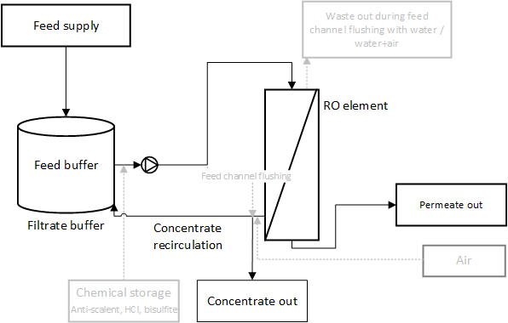

**Figure 2.** Schematic overview of the RO module.

## Granular Activated Carbon (GAC)

In granular activated carbon treatment, large uncharged molecules attach to the surface of the carbon. The granules of the carbon have 3 classes of pores – macropores with diameter larger than 50 nm, mesopores with diameter 2-50 nm and micropores with diameter smaller than 2 nm. Typically, after use, the carbon is being replaced and sent to regeneration which can be done using either steam or thermal regeneration typically at 800 oC and controlled atmosphere.

The activated carbon can also be used as biologically activated carbon, where biofilm is growing on the carbon and consumes biodegradable components. In this case, the carbon is not being replaced, but only backwashed to remove the excess biofilm when the pressure drop becomes excessive using filtrate water.

In the IMPROVED containers, there are 3 columns, which are operated in series as GAC1, followed by GAC2 and GAC3.

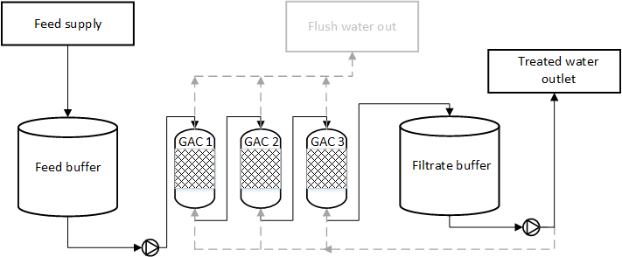

Figure 3 Process diagram of the granular activated carbon in the IMROVED containers

## Electrodialysis

Electrodialysis is a desalination technique in which separation of ions and water is achieved by applying an external potential across semipermeable membranes. Here, Anion Exchange Membranes (AEM) and Cation Exchange Membranes (CEM) are altered in the ED unit in order to establish desalination of the diluate stream and to transport the ions to the concentrate. A general overview of the ED layout is provided in Figure 4.

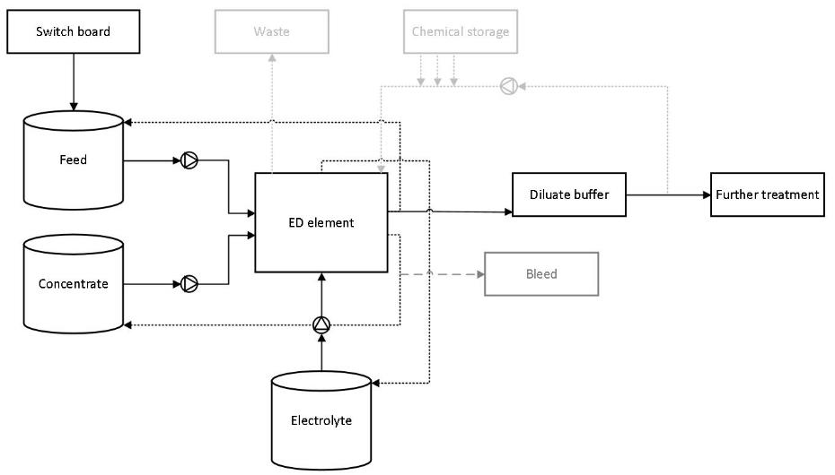

**Figure 4**. Schematic overview of the ED module.

The concentrate compartment of the ED in IMPROVED is always recirculated. Once the maximum set concentration is achieved, a volume of the concentrate tank is pumped out and replaced with fresh feed. The diliate compartment can be operated either with a recirculation until a certain quality is achieved, or as a single pass and pumped out to further treatment in another unit.

A more in-depth view on the working mechanism of the ED module, with the respective cell pair configuration, is shown in Figure 5.



**Figure 5.** Separation mechanism in an ED module [1].

The electrode rinse in Figure 6 is the electrolyte, which was a solution of NaNO3 (15 mS/cm) for the CTBD water that was periodically acidified to pH 3 to prevent scaling on the electrodes using HNO3.

## Ultrafiltration

The ultrafiltration is a process where suspended solids are filtered over a membrane with small pores. This process is commonly used as a pretreatment process for reverse osmosis. The membranes used in UF can be backwashed periodically and are resistant to low levels of free chlorine allowing cleaning in place with bleach.



Figure 4 Simplified schematics of the UF skid

# Materials and Methods

## Reverse osmosis

In Figure 2, the scheme of the RO set-up is shown. The RO membrane was a Dupont Filmtec LC LE-4040, with an active membrane area of 8.7 m². The pressure housing was a Codeline 40E100. The pH, flow, pressure, conductivity, temperature were continuously measured online with 2-minute sampling intervals. Antiscalant from Genesys specific to barium sulfate scaling was dosed in 5 ppm concentration.

The flux was set to 20 l/(m2.h) and the recovery was set to 75%.

## Granular activated carbon

The setup of the containers (Figure 3) consists of 3 columns in series with diameter of 26 cm, height of 1 m, filled until 0.81 m, resulting in 43 L volume each. The carbon used in the tests was Norrit GAC 830W. The normal operational flow of the columns is from top to bottom with a flow rate of 250-500 l/h. The backwash is performed in the opposite direction from the bottom to the top.

## Electrodialysis

The electrodialysis test were performed in the premises of the stack manufacturer REDstack at Afsluitdijk. The stack had 22x22cm with 10 channels and total membrane area of 0.97 m2. The feed flowrate was 38 l/h and the compartment thickness was 0.48 mm. The electrolyte rinse solution was Na2SO4 acidified to pH 3-3.5 using H2SO4 with electrolyte flowrate of 84 l/h. Full reversals of the flows and the current direction were done every 30 minutes. The recovery was set to 50 % - i.e. no recirculation of the concentrate, but a single pass.

## Ultrafiltration

The UF in the IMPROVED containers is based on two identical hollow fiber modules from INGE model Dizzer P 4040-6.0 operated in parallel. One of the modules can be isolated from the system by closing down manual valves in case lower production of flowrate is required. The system automatically alternates between filtration, drain, backwash and forward flush modes. In filtration the permeate tank is filled first before outputting water to the next technology. During drain cycle the modules are drained of water and the filtered suspended solids. During backwash the water is rapidly pushed in the opposite direction and the filtered cake material is dislodged from the membrane surface. Finally, the feed space of the modules is flushed before going back into filtration mode. The permeate tank was not dosed with chemicals.

The flux was set to 35 l/m2/bar and the filtration time was 30 to 60 minutes with backwash duration of 15 to 30 seconds at 1.9 bar.

# Results and Discussion

## Time schedule

The RO train was initially operated between 8-Aug and 11-Oct as GAC-UF-RO train. Following this run from 13 Oct until 9th of November the GAC was removed and the train was operated as UF-RO to evaluate the impact of the GAC pretreatment. GAC-UF-RO was the longest operated train as it performed consistently good in terms of quality and stability. The lamella tests did not yield good results and were therefore shortly abandoned and are not discussed in this report.

|  |  |  |  |  |  |  |  |  |  |  |  |  |  |  |  |  |
| --- | --- | --- | --- | --- | --- | --- | --- | --- | --- | --- | --- | --- | --- | --- | --- | --- |
|  | 07-Aug | 13-Aug | 19-Aug | 25-Aug | 31-Aug | 06-Sep | 12-Sep | 18-Sep | 24-Sep | 30-Sep | 06-Oct | 12-Oct | 18-Oct | 24-Oct | 30-Oct | 05-Nov |
| GAC-UF-RO |  |  |  |  |  |  |  |  |  |  |  |  |  |  |  |  |
| UF-RO |  |  |  |  |  |  |  |  |  |  |  |  |  |  |  |  |
| GAC-EDR |  |  |  |  |  |  |  |  |  |  |  |  |  |  |  |  |
| Lamella |  |  |  |  |  |  |  |  |  |  |  |  |  |  |  |  |

## Feed water quality

The conductivity and TOC of the feed water during the testing period can be seen below:

Figure 5 TOC and conductivity of the feed water

Since the TOC analyzers at the containers were not serviced until September 3, the results before this date were analyzed in the lab of Dow. Normally the water fed to this cooling tower is a blend between surface water from the Belgian polders and treated wastewater from the Dow BIOX plant. However, at the end of Аugust the cooling tower was switched to complete feed from the BIOX WWTP which explains the change in trend of the conductivity and TOC.

The cations in the feed water can be seen in Figure 6 and Figure 7:

|  |  |  |
| --- | --- | --- |
|  |  |  |
| Figure 6 Main cations in the feed water |  | Figure 7 Cations in trace quantities |

As seen the main cations are sodium and calcium with around 50 ppm of potassium and magnesium. In terms of trace elements, zinc is found at 1 to 1.5 ppm which is added as a corrosion protection agent by Dow and Barium is indeed found in concentrations of around 0.15 ppm. Barium is a special scaling element which forms irreversible scaling as barium sulfate even such low levels according to Membrane Master 5, the scaling prediction tool from Genesys.

In terms of anions, the main anion in the system was sulfate 1000 to 1200 ppm and chloride at 400-500 ppm. Some nitrite was detected at around 50 ppm and trace amounts of fluoride - Figure 8

|  |
| --- |
|  |
| Figure 8 Anions in the feed |

Special attention was paid to the concentration of 4/5-1H-Methylbenzotriazole and its breakdown product benzotriazole as this chemical is added for copper corrosion protection, but was believed to be the main fouling component of the NF membranes in the E4Water project. Several testing campaigns were done Figure 9:

|  |
| --- |
|  |
| Figure 9 Concentration of 4/5-1H-Methylbenzotriazole and Benzotriazole in the feed water |

The concentration of 4/5-1H-Methylbenzotriazole varied quite a lot from 500 to over 2000 ppb. But benzotriazole was always below 4 ppb and mostly below its detection limit of 2 ppb.

## Performance of RO train

### Performance of GAC

The GAC was operated during the whole trial period. The GAC was operated at 300 l/h in the GAC-UF-RO train and 500 l/h in the GAC-EDR train. The GAC was generally backwashed once per week with around 100 l resulting in water efficiency higher than 98%. The backwash was needed as the extra biomass growing on mainly the first column was increasing the pressure drop - Figure 10.

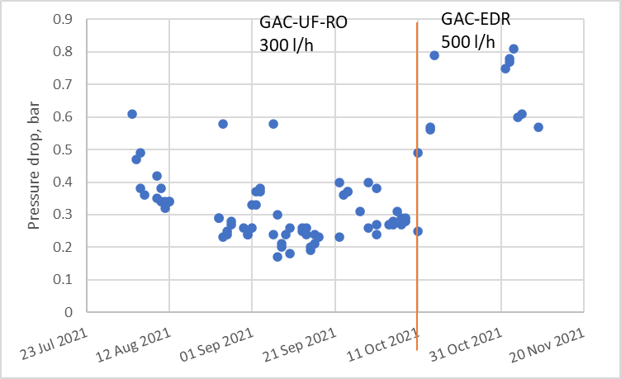

Figure 10 Pressure drop measured before the first GAC column

The biology immediately started to develop on the surface of the carbon, indicated by the reduced dissolved oxygen as shown in Figure 11.

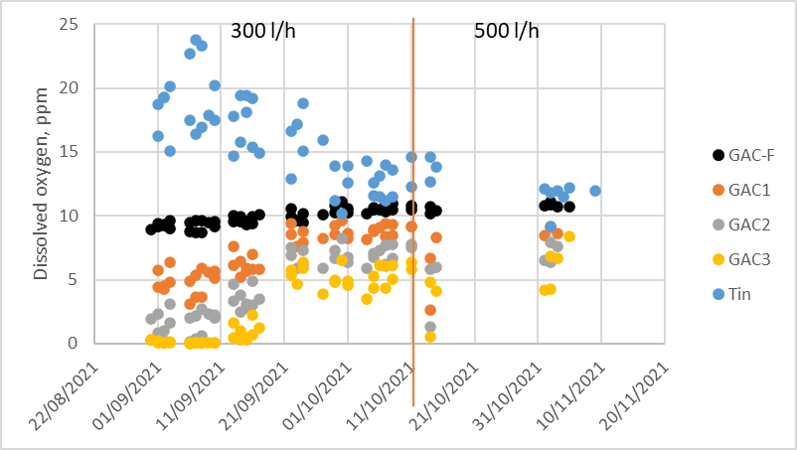

Figure 11 Dissolved oxygen evolution in the GAC

It should be noted that the DO utilization of the GAC was strongly correlated to the influent temperature. At feed temperatures above 15 oC, the outlet of the last GAC column was below 1 ppm of oxygen. The feed temperature was strongly dependent on the ambient temperature due to 70 m long feed lines to the IMPROVED containers. The development of the biological community in the GAC confirms that any residual free chlorine added 2x/day to the cooling tower is removed effectively by the GAC. The free chlorine was never measured in the containers and the number was taken from communication with Dow.

The GAC also removed significant amount of turbidity as seen in Figure 12

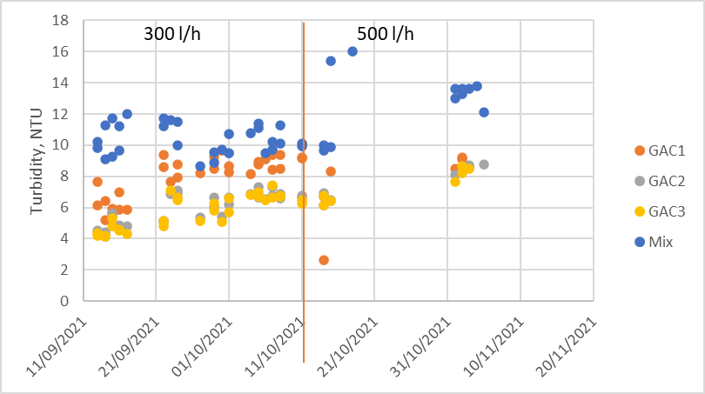

Figure 12 Turbidity evolution in the 3 GAC columns

TOC was significantly and consistently reduced by the GAC as can be seen in Figure 13:

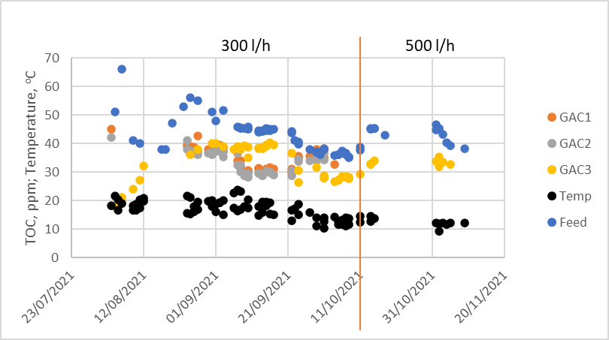

Figure 13 Feed temperature and TOC removal by the 3 GAC columns

As seen, after about a month of operation the TOC removal of the GAC greatly diminished, which was attributed to the absorption capacity being exhausted. Nevertheless, the GAC continued to remove at least 10 ppm of TOC based on biological degradation (BGAC), mechanical filtration and agglomeration of biopolymers and residual absorption capacity for components with high affinity to GAC. This biologically activated GAC does not need to be replaced regularly as it only serves as a buffer for the feed water concentration and as a carrier to the biology. It also serves the purpose of mechanical filtration as well as reduction site for removal of free chlorine.

In terms of removal of 4/5-1H-Methylbenzotriazole and benzotriazole removal, the GAC was performing very good and 4/5-1H-Methylbenzotriazole were almost completely removed most of the time (Figure 14):

|  |
| --- |
|  |
| Figure 14 Concentration of 4/5-1H-Methylbenzotriazole and benzotriazole after GAC3 |

Even though the GAC was operated for more than 3 months the benzotriazole was most of the time removed even in the first GAC column (measured only 90 ppb on Sep 13 after GAC 1). This means that the GAC acts as a very good barrier to protect the RO from benzotriazole-related fouling.

### Performance of UF

The Ultrafiltration was operated during the whole duration of the trials either with or without GAC pretreatment. It should be noted that logging was not available in the first 3 weeks of operation due to lack of alarm cables to the control room of Dow.

Initially the UF was operated at flux of 70 LMH which resulted in severe blocking and the system did not last more than two days before cleaning in place was necessary. Afterwards, the flux was reduced to 35 LMH and generally the system had to be cleaned in place (CIP) once per week.

The UF was operated at 30 minutes filtration time, followed by module drain, 30 seconds backwash at 1.9 bar and forward flush.

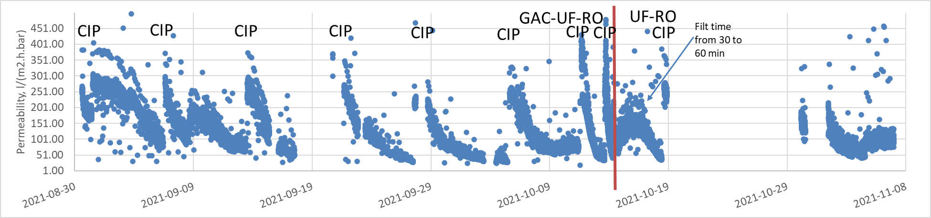

Figure 15 Viscosity normalized permeability for the UF

In Figure 15 the frequencies of CIP can be clearly seen as the permeation gradually decreases over time and is restored to baseline of ~300 l/(m2.h.bar). It should be noted that after each CIP the permeability of the UF was returning to baseline, so permanent blocking of the membranes was not observed.

Regarding the CIP protocol, initially the membranes were cleaned only with NaOH soak at pH 12 for one hour. Later it was found that soaking the membrane first at pH 2 for one hour resulted in better recovery of the membrane. From Oct 5 NaOCl at 100 ppm free chlorine was added to the NaOH soak.

Since the permeability of the UF increased in the UF-RO train, the filtration time was increased from 30 to 60 minutes. This increase was attributed to the 2-3 ppm of free chlorine dosed daily by Dow being able to control the biofouling on the membrane. Even with doubled filtration time, the UF permeability remained rather stable at 100 l/(m2.h.bar) and never decreased to 50 l/(m2.h.bar) as was the case with GAC-UF-RO. The UF was also operated for longer periods of time without needing CIPs. The last UF CIP was performed on 10/18/21.

The free chlorine dosed at 2-3 ppm 2x per day by Dow was neutralized on the GAC in the GAC-UF-RO scheme and was able to directly reach the UF in the UF-RO scheme. Since this free chlorine was able to enhance the operation of the UF, it is advisable to explore Chemically Enhanced Backwash (CEB) where bleach is dosed in the backwash solution. In chemically enhanced backwash, small doses of free chlorine are dosed in the backwash water and the backwashes every 30-60 minutes will suppress the biofouling happening on the UF.

The TOC removed by the UF was in the order of 2-3 ppm (Figure 16):

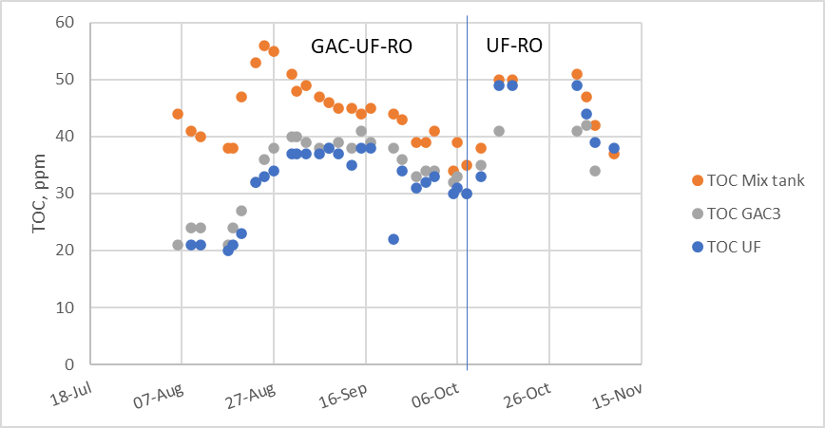

Figure 16 TOC removal by the UF

### Performance of RO

Reverse osmosis has been tested as part of the treatment trains during the cooling tower blowdown treatment. Reverse osmosis was part of the first treatment train GAC-UF-RO, and the necessity of GAC was tested with a treatment train of UF-RO. RO experiments were done with a new Dupont Filmtec LC-LE 4040 membrane.

The operation of the membrane started with a flux of 15 l/(m2.h) and was increased to 20 l/(m2.h) after 4 weeks of operation. From mid-August the water recovery was increased from 60% to 75%. The pH was controlled at pH 6.3. Antiscalant was also dosed, starting with Nalco Permatreat 191T, and mid-August changed to a barium sulfate specific antiscalant from Genesys (Genesys BS). The barium sulfate specific antiscalant was selected as previous reports from E4Water indicated this scaling component in the water and the antiscalant was selected based on simulation with Genesys Membrane Master 5 software.

The conductivity of feed, permeate and concentrate are shown in Figure 17.

The feed water is concentrated by recycling the water through the membrane into the feed buffer tank, hence the conductivity of the feed tank much higher than the conductivity of the actual feed.

The RO in the IMPROVED containers works by recirculation, therefore the RO feed tank concentration (RO-F) has about 3-4x higher conductivity than the feed water itself, therefore the concentration is much higher in the RO-feed (Figure 17). The increase of conductivity of the feed since the beginning of September is also due to the increased recovery from 60 to 75%.

|  |
| --- |
|  |
| Figure 17 Conductivity of RO feed buffer tank, permeate and concentrate |

#### Normalized RO data

The normalized data for reverse osmosis is shown in *Figure* 18 and *Figure* 19. The nominal pressure drop (NPD) is the pressure drop of the feed channel normalized for temperature effects on the viscosity as well as variation of the flowrate – Appendix A.2. The normalized membrane permeability indicates the resulting membrane flux per applied pressure, normalized for temperature effects on the viscosity – Appendix A.2. It should be stated that the data until the end of August is unreliable, as the flow meters were failing (indicated with a vertical grey line). Two cleanings in place have been done in the testing period, which are indicated with vertical red lines.

|  |  |
| --- | --- |
|  | |
| Figure 18 Nominal pressure drop and net driving pressure of RO membrane during CTBD treatment (Grey line: Flow meters calibrated, Red line: CIP, Black line: change of treatment train) | Figure 19 Membrane permeability of the RO membrane during CTBD treatment |

During the experiments three cleanings in place (CIP) were done with 1h soak using HCl (pH 2), followed by 1 h soak using NaOH (pH 12) together with an RO cleaner from Genesys (Genesol 34) at 3% (vol). These cleaning in place events can be seen as vertical red lines in *Figure* 18 and *Figure* 19.

Overall, during the GAC-UF-RO the RO was running very stable and the CIP events were done due to failure to dose antiscalant or acid caused by accidental running out of chemicals or air-lock of dosing pumps.

The normalized feed channel pressure drop (blue in *Figure* 18) increased slowly after startup, but remained around 0.5 bar showing no significant feed spacer fouling.

The net driving pressure (green in *Figure* 18) shows an increasing trend over time for both the GAC-UF-RO and UF-RO configurations suggesting membrane fouling. However, the increasing trend of the pressure is much more severe without the GAC. During the first CIP the pressure was recovered to values around 4 bar, while it recovered to 5 bar after the second CIP. The cleanings in place were necessary after a period with insufficient antiscalant dosage. Immediately after removing the GAC from the treatment train, there is a rapid increase in the net driving pressure.

The membrane permeability denotes, the flux per applied pressure *Figure* 19. Since the flux is constant for most of the part, this graph is the inverse of the NPD in *Figure* 18. The permeability decreases much faster in the UF-RO configuration. When the last CIP was performed on Nov 3, it had little and very short effect on the membrane permeability, suggesting the fouling that happens without the BGAC is irreversible.

Overall, it can be concluded that GAC-UF-RO is stable over time, although the pressure and permeability had a slight increasing trend over time. This increase can be counteracted by more frequent CIP events. Besides that, removing GAC from the treatment train fouls the RO membrane, indicated by the increase in net driving pressure and the decrease in membrane permeability. The hypothesis is that methylbenzotriazole is removed by GAC and will end up on the RO membrane without GAC as pre-treatment.

### Quality obtained by RO treatment

The conductivity of the RO permeate can be seen in Figure:

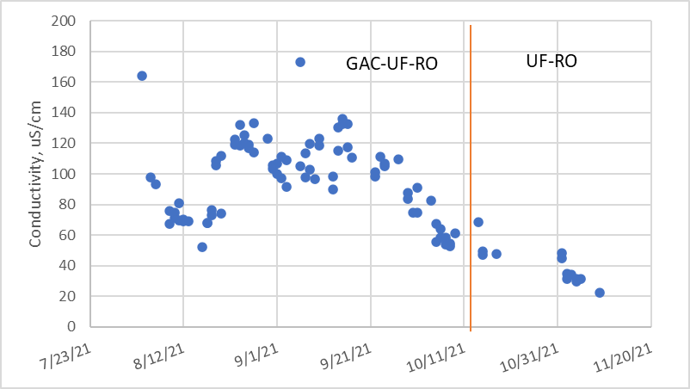

Figure 20 Conductivity of the RO permeate

The conductivity of the RO was about 100-120 µS/cm in the GAC-UF-RO and 20-60 µS/cm in the UF-RO configuration. This higher conductivity in the GAC train was attributed to the CO2 produced by the biology in the GAC, which can later pass the RO since CO2 is not very well rejected. However also the Na content of the permeate is lower, which suggests improved membrane rejection based on the membrane (bio)fouling.

In terms of TOC, the performance of RO was excellent with GAC in the train and much worse in the UF-RO configuration (Figure 21):

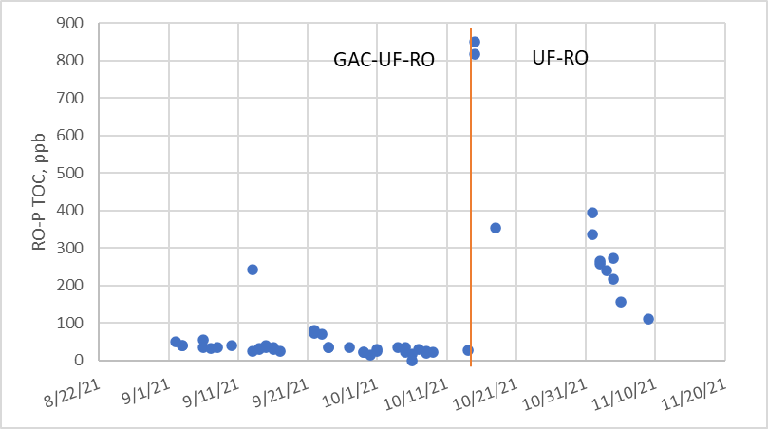

Figure 21 TOC of the RO train

Somewhat expectedly the TOC increased from 30 to 850 ppb when the GAC was removed from the train. The biology in the GAC can remove the small, biodegradable organics that normally passes the RO membrane. However, it was a bit unexpected that the RO continued to decrease in the UF-RO configuration to the point that it almost reached the GAC-UF-RO quality. When looking at the graph, one should consider that the net driving pressure of the RO (*Figure* 18) also increased more than 3x due to fouling in the UF-RO configuration. This can certainly improve the rejection of the RO. Blocked pores of the membrane also lead to increased rejection. Moreover, the RO membrane autopsy (Appendix A.1 Membrane autopsy of the RO fouling after the UF-RO tests) showed a lot of organic fouling and biofouling, therefore the development of microbial community on the RO surface can also improve the RO rejection.

In terms of cationic rejection the most prominent ion in the permeate was sodium, followed by calcium – Figure 22:

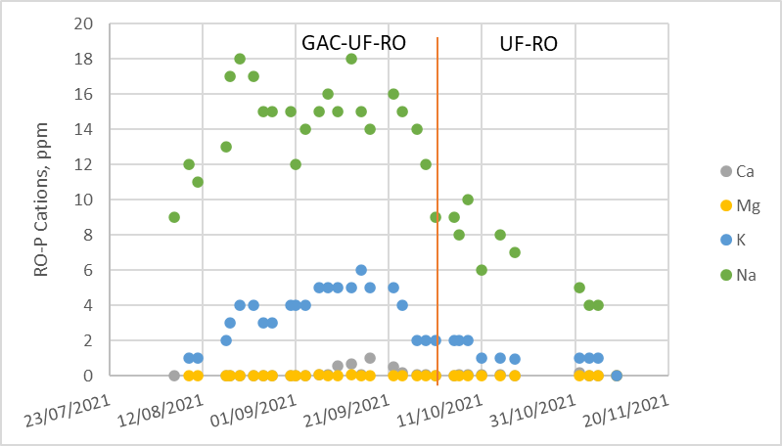

Figure 22 Cations in the RO permeate

The anions found in the RO permeate can be seen on Figure 23:

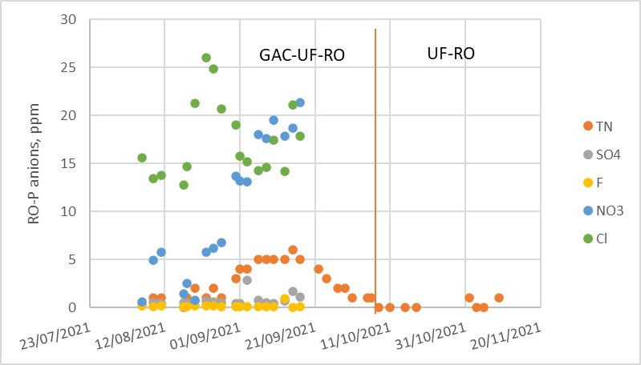

Figure 23 Anions in the RO permeate

The ions passing the membrane the most are nitrate and chloride. Sulfate rejection was exceptionally good. Unfortunately, anion analysis was not performed for the whole period due to practical reasons.

## Performance of the EDR treatment

Since the operation of the EDR at the IMPROVED containers was unstable, the EDR testing was done at the site of the EDR manufacturer REDstack at Afluitdijk. One IBC of cooling tower blowdown was supplied and REDstack performed the tests with the same stack as the one supplied at the IMPROVED containers at 50% water recovery without any pretreatment and without the addition of antiscalants. The electrode rinse solution was Na2SO4 with pH reduction to pH 3-3.5 using H2SO­4. The obtained results are summarized in Table 1:

Table 1 Results obtained with the EDR stack at the REDstack premises at Afsluitdijk

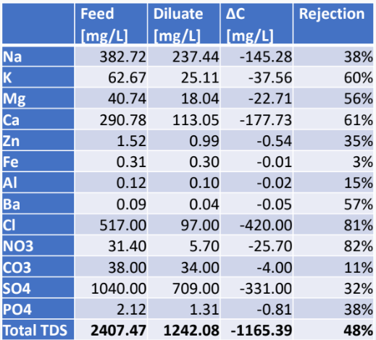

The single pass desalination revealed 48.4% desalination based on TDS and product quality of 1.8 mS/cm. The desalination energy was calculated to be 0.45 kW-h per 1 m3 of produced desalinated water based only on the power supply data. The conductivity of the diluate was 1.8-1.9 mS/cm and the TOC was 34-39 ppm.

The operation of the EDR was deemed stable during these trials.

## Chemical usage

### GAC

During the trials, no chemicals were used in the operation of the GAC

### UF

In the operation of the UF, hydrochloric acid, sodium hydroxide, sodium hypochlorite and sodium bisulfite were used for cleaning in place normally once per week. The sodium bisulfite (NaHSO3) was used to quench the free chlorine after the CIP in order to protect the RO membrane from oxidation. The usage of chemicals is normalized per m3 of produced water in Table 2:

Table 2 Chemical usage in the operation of UF normalized per m3 of produced water

|  |  |
| --- | --- |
| Chemical | Dosage, ppm |
| HCl, 30% | 7 |
| NaOH, 25% | 7 |
| NaOCl, 14% free chlorine | 0.7 |
| NaHSO3, 40% | 0.5 |

### RO

During the normal operation of RO, only antiscalant and hydrochloric acid were dosed for scaling control. Both the acid and antiscalant were dosed continuously and the pH was controlled between 6.3 and 6.6. The usage of chemicals is normalized per m3 of produced water in Table 3:

Table 3 Usage of chemicals in the operation of RO

|  |  |
| --- | --- |
| Chemical | Dosage, ppm |
| HCl | 85 |
| Genesys BS antiscalant | 5 |

The RO was also cleaned in place two times in the GAC-UF-RO operation configuration and once in the UF-RO configuration. Since the cleaning in place was needed due to dosing errors in the GAC-UF-RO configuration, this chemical consumption is ignored.

In the UF-RO configuration, sodium bisulfite needs to be dosed in order to quench the 2-3 ppm of free chlorine in the blowdown dosed 2x per day by Dow. Normally sodium bisulfite is needed in 1.5x the molar ratio of free chlorine. However, this configuration was not stable due to severe fouling of the RO and the chemical consumption is therefore irrelevant.

### EDR

### During the trials of EDR at REDstack, no chemicals were used.

## Integration of the treatment train at the Dow plant

Clearly, the permeate of GAC-UF-RO can be reused as boiler feed water source at the plant of Dow. However, when it comes to reusing the GAC-UF-RO or EDR treated water into the cooling tower, the situation is more complex. This complexity comes from two factors:

* If the permeate is with lower or higher conductivity than the current make-up water, the amount blowdown set tot the treatment stage will be less or more, respectively. The flowrates will then have to be calculated iteratively.
* The rejection of the treatment stages is not the same for each ion and the rejection of organics (TOC) greatly differs between the two treatment options. Therefore, there is a risk that the ionic composition and the composition of organics in the cooling tower might change once water is reused.

In attempt to answer these questions, a simple excel model was developed. The excel model accepted the following assumptions:

* The concentration is proportional to conductivity
* The model iteratively adjusts the flows in configuration with treatment steps, to have the same conductivity of the blowdown as the current system
* The average make-up composition was given by Dow, it is assumed that all components in the list are completely rejected in the evaporation process inside the cooling tower
* The per-ion rejection of EDR was taken from the Afsluitdijk experiments of REDstack and the RO configuration rejection was taken from the AquaSPICE trials

Assumption that concentration is proportional to conductivity allows us to use the equation Q1.σ1=Q2.σ2, where Q is flow rate and σ is conductivity in order to calculate the flow rates in the system.

### Current situation

In the current situation, the flow rates and conductivity values are represented by Figure 24:

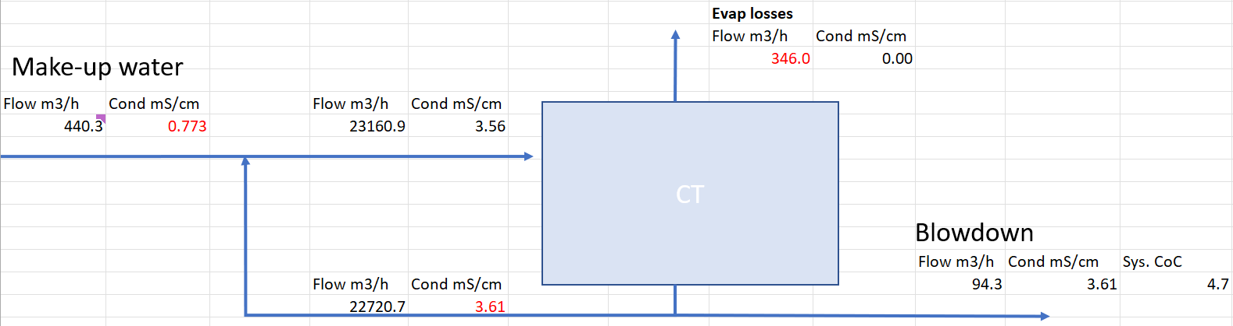

Figure 24 Current situation of water usage in the largest cooling tower of Dow

The cooling tower is fed with 440 m3/h of make-up water, evaporates 346 m3/h and produces 94 m3/h of blowdown. Based on the ratios of make up to blowdown, one can assume a concentration factor of 4.7 for non-volatile components. The recirculation flow of the cooling tower can also be calculated, assuming 1.5 % evaporation of the recirculation flow. This recirculation flow was confirmed by Dow, but in fact has no weight on the further outcome of the model. The values in red are kept constant in all calculations – the make-up water quality cannot be changed, the blowdown conductivity needs to be the same in order to not disturb the operation of the cooling tower and the capacity of the cooling tower needs to remain the same.

### Integrating GAC-UF-RO treatment

According to the model calculations a case where RO permeate is reused is depicted in Figure 25:

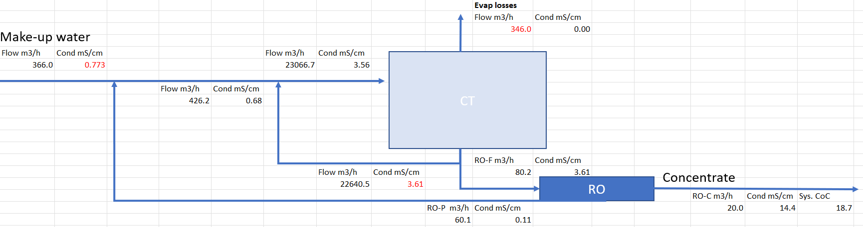

Figure 25 Case where RO is used to treat the cooling tower blowdown

One should note that the values in red are the same as the conventional case. Since the quality of the RO permeate is better than the make-up water, the amount of blowdown sent to treatment is also less at 80 m3/h, compared to 94 m3/h for the conventional case. The RO concentrate produced is only 20 m3/h resulting in overall system cycles of concentration (CoC) of 18.7. Based on make-up water reduction this case can save 650 000 m3/y of water.

### Integrating EDR treatment

According to the model calculations a case where EDR diluate is reused is depicted in Figure 26:

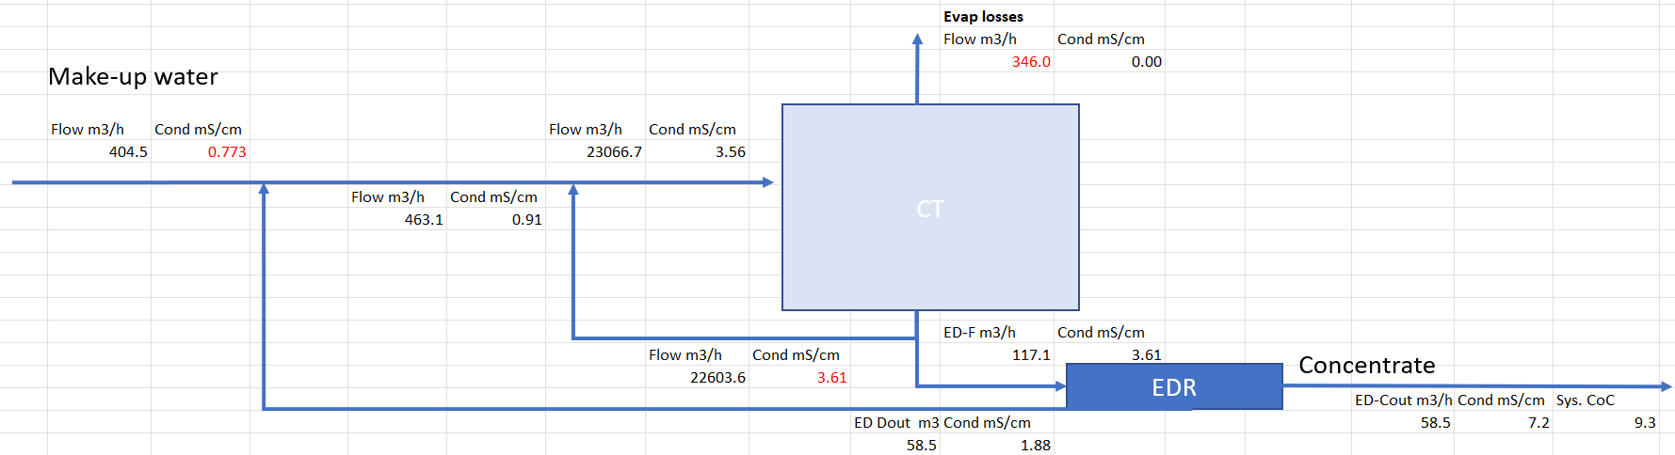

Figure 26 Case where EDR is used to treat the cooling tower blowdown

The EDR water quality is lower than the make-up in terms of conductivity. This is still 2x better quality than the cooling tower blowdown, so the diluate water can be reused. Because of this lower quality, more water needs to be sent to the treatment stage in order to keep the same conductivity of blowdown – 117 m3/h compared to 94 m3/h in the conventional scheme and 80 m3/h in the RO scheme. This needs to be considered, since the flow rate sent to the treatment stage largely dictates the size of the installation and hence the CAPEX costs. The EDR can be built with a second stage where better quality is produced and recovery is increased, which should decrease the flow rate sent to the EDR, so the system configuration can be further optimized. However, one should be careful of accumulating components that are rejected poorly by the EDR such as organics. The system produces 58 m3/h of concentrate, compared to 94 m3/h for the conventional case. Based on make-up water reduction this case can save 313 000 m3/y of water.

### Studying per-ion performance of the treatment options

In order to find how certain ions can accumulate or be reduced by reusing the blowdown, the following rejections and make up quality were taken - Table 4:

Table 4 Make up quality and rejections

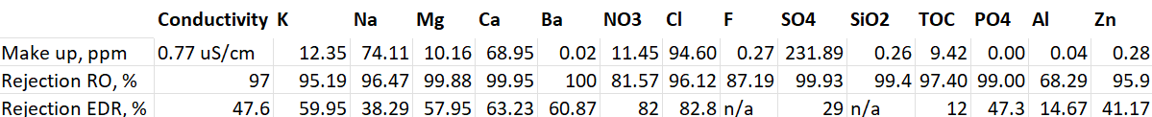

The make-up quality was presented by Dow, the rejection of the RO train was taken from the AquaSPICE trials and the EDR rejection was taken from the Afsluitdijk trials of REDstack.

Based on the make-up quality the model assumes 100% rejection for the cooling tower. Once this is done, the model can predict the accumulation of ions inside the cooling tower blowdown - Table 5:

Table 5 Predicted blowdown quality for different treatment options

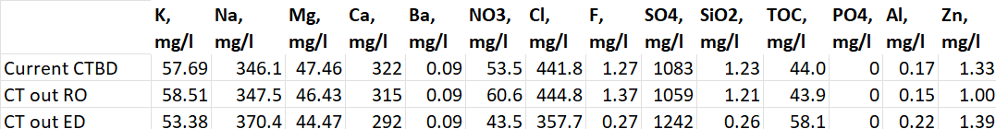

For most ions the RO integration would result in very small differences due to the very good rejection of the RO for most ions. Small exception is the NO3 ion since the rejection of RO is rather low in this case.

However, for the EDR case, the rejection differs very much for each component and the composition of the blowdown can change significantly. The hardness ions Mg and Ca are well rejected by the EDR and the recovery is rather low, so these ions are actually decreased in the system. Similar are the cases with NO3 and Cl, which are also reduced. Since hardness leads to scaling and Cl leads to corrosion, the reduction of these ions is welcome. However, SO4 and TOC are significantly increased. In fact, Dow wants to keep the SO4 below 1200 ppm and the TOC below 50 ppm, respectively, therefore even at 50 % recovery, these parameters are exceeded by the EDR case.

# Conclusions

Table 6 Main performance indicators of the different technological trains

|  |  |  |  |  |  |  |  |  |  |  |
| --- | --- | --- | --- | --- | --- | --- | --- | --- | --- | --- |
| **Train** | **Recovery, %** | **Cond, uS/cm** | **TOC, ppm** | **Na, ppm** | **K, ppm** | **Ca, ppm** | **Mg, ppm** | **Cl, ppm** | **SO4, ppm** | **NO3, ppm** |
| GAC-UF-RO | ~70 | 60-140 | 0.02-0.05 | 9-18 | 1-6 | 0-1 | 0 | 13-26 | 0-3 | 1-22 |
| UF-RO | ~71 | 20-60 | 0.1-0.85 | 1-2 | 4-10 | 0 | 0 | n/a | n/a | n/a |
| EDR* | ~50 | 1800-1900 | 34-39 | 237 | 25 | 113 | 18 | 97 | 709 | 6 |

*All EDR results obtained in testing at REDstack facilities

The tests at Dow Terneuzen proved that very high-quality water can be achieved using GAC-UF-RO configuration. This water is perfectly suitable as a source for boiler feed water production based on the extremely low TOC of <50 ppb, however the conductivity was somewhat high at 100 µS/cm which would require a second pass RO or polishing using IEX train before sending to mixed bed treatment. The configuration was also very stable in terms of operation for RO and GAC. The UF needed a weekly cleaning in place, which was attributed to biofouling. This biofouling can be controlled in a full-scale installation using chemically enhanced backwashed using bleach. The recovery of the overall train was around 90 %.

The UF-RO configuration produced water with higher TOC, up to 850 ppb, but lower conductivity of around 50 µS/cm. The RO was not stable and fast, irreversible fouling occurred. This fouling was attributed to biofouling, TOC fouling and probably benzotriazole and derivatives related fouling.

The EDR was also tested both inside the IMPROVED container and in the piloting facility of REDstack at Afsluitdijk. The quality of the produced water was 1.8 mS/cm which is still lower than the cooling tower blowdown (~3.5 mS/cm) and can be sent back to the cooling tower. However, it should be noted that the recovery of the EDR was tested only until 50%.

Integrating the RO step would help save 17% of the make-up water, while the EDR could save 8%. The quality of the cooling tower is expected to remain the same if the RO step is implemented. The recovery of the EDR can be further increased but chemicals such as antiscalants and acid for pH control need to be dosed and certain ions such as SO4 and organics can begin to accumulate in the cooling tower.

# Acknowledgments

The authors would like to acknowledge the European Commission for funding the AquaSPICE project. The AquaSPICE project has received funding from the European Union’s Horizon 2020 research and innovation programme under grant agreement No 958396.

# References

|  |  |
| --- | --- |
| [1] | A. E.-G. K. E.-Z. Heba ABDALLAH, "Hydrophobic polyethersulfone porous membranes for membrane distillation," *Frontiers of chemical science and engineering,* pp. 84-93, 2015. |
| [2] | Lenntech, "Hydranautics, RO water chemistry," 09 01 2019. [Online]. Available: https://www.lenntech.com/Data-sheets/Hydranautics-RO-Water-Chemistry-LL.pdf. [Accessed 09 01 2019]. |
| [3] | N. S. ALZAFIRI, "The effectiveness of antiscalants when used on multistage flash distillers (Doctoral thesis)". |
| [4] | K. D. D. a. A. Ketsetzi, "Degradation of Phosphonate-Based Scale Inhibitor Additives in the Presence of Oxidizing Biocides: “Collateral Damages” in Industrial Water Systems," *Separation Science and Technology,* vol. 42, pp. 1639-1649, 2007. |
| [5] | H. Strathmann, "Electrodialysis," *Encyclopedia of Membranes,* 2016. |
| [6] | I. Hitsov, L. Eykens, W. D. Schepper, K. D. Sitter, C. Dotremont and I. Nopens, "Full-scale direct contact membrane distillation (DCMD) model including membrane compaction effects," *Journal of Membrane Science,* vol. 524, pp. 245-256, 2017. |
| [7] | P. M. /. R. T. I. IWC-99-64, "BEHAVIOR OF SILICA IN ION EXCHANGE AND OTHER SYSTEMS," [Online]. Available: https://snowpure.com/docs/resintech-silica-iwc99.pdf. [Accessed 31 01 2019]. |
| [8] | S. Derese, *Towards innovative technologies for nutrient recovery from human urine, Doctoral Thesis,* UGent, 2018. |
| [9] | H. Huiting, M. de Koning and E. F. Beerendonk, "Normalisatie van gegevens bij nanofiltratie en omgekeerde osmose," KIWA-VEWIN SWI 199.66, 1999. |
| [10] | B. Malfroot, "Lab-scale and pilot-scale investigation of condensate polishin units," UGent, 2019. |
| [11] | T. V. Overstraeten, "Water reuse and alternative water sources," Ghent University, Ghent, 2018. |
| [12] | D. W. Solutions, "https://water.custhelp.com," Dupont, [Online]. Available: https://water.custhelp.com/app/answers/detail/a_id/4219/~/dow-water-and-process-solutions_-correlation-between-kmno4,-cod,-bod,-doc. |
| [13] | S. w. t. a. solutions, " Handbook of Industrial Water Treatment," [Online]. Available: https://www.suezwatertechnologies.com/handbook/chapter-19-condensate-system-corrosion#EFFECT%20OF%20pH%20ON%20CORROSION%20OF%20IRON%20AND%20COPPER. |
| [14] | i. K. D. ROY, *Microbial resource management: introducing new tools and ecological theories,* Ghent: UGent, 2014. |

# List of abbreviations

|  |  |  |
| --- | --- | --- |
| BGAC |  | Biological granular activated carbon |
| CapEx |  | Capital Expenditure |
| CIP |  | Cleaning in place |
| COD |  | Chemical oxygen demand |
| DO |  | Dissolved oxygen |
| EDR |  | Electrodialysis reversal |
| GAC |  | Granular activated carbon |
| IC |  | Inorganic carbon, ion chromatography |
| IEX |  | Ion exchange |
| IMPROVED | | Integrale Mobiele PROceswater Voorziening voor een Economische Delta |
| MB |  | Mixed bed resin |
| MTC |  | Mass transfer coefficient |
| NSP |  | Normalized salt passage |
| OpEx |  | Operational Expenditure |
| RO |  | Reverse osmosis |
| TC |  | Total Carbon |
| TOC |  | Total organic carbon |

# Appendices

# A.1 Membrane autopsy of the RO fouling after the UF-RO tests

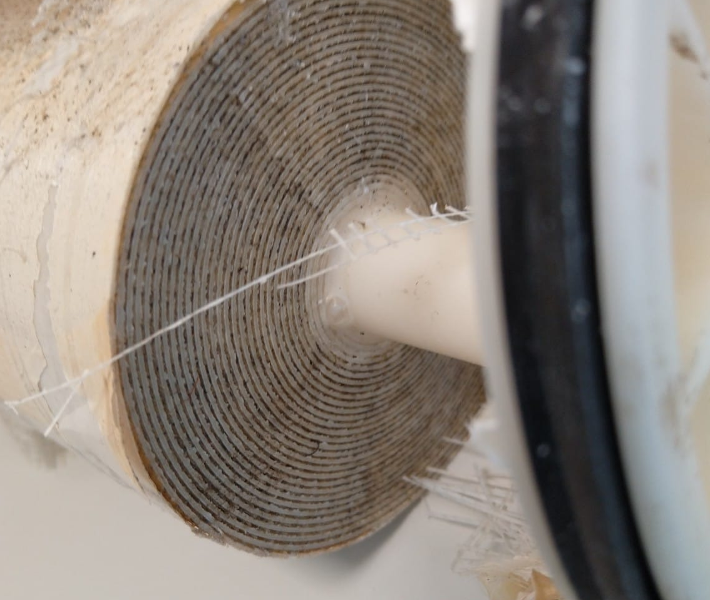

Figure 27 Feed side spacer entrance

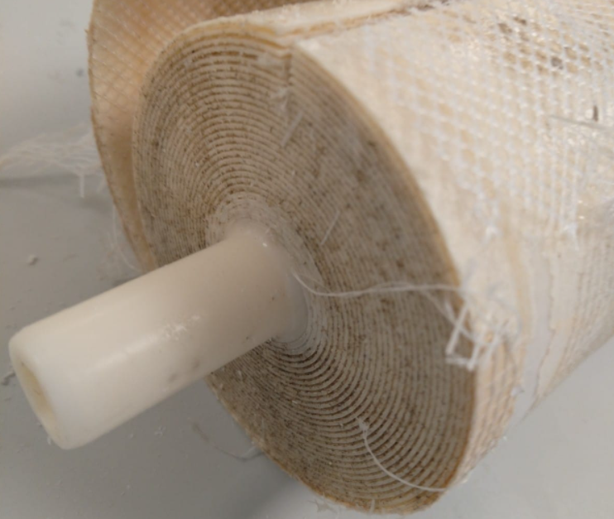

Figure 28 Permeate side spacer exit

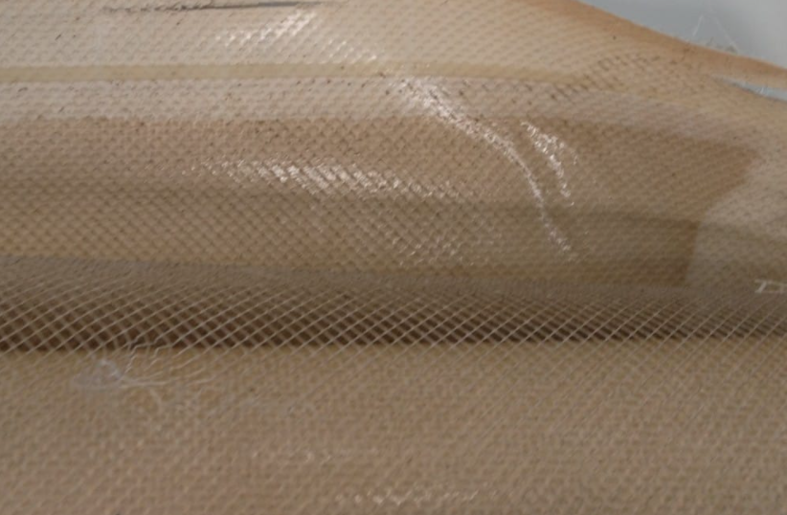

Figure 29 Fouling near the feed side of the membrane envelope

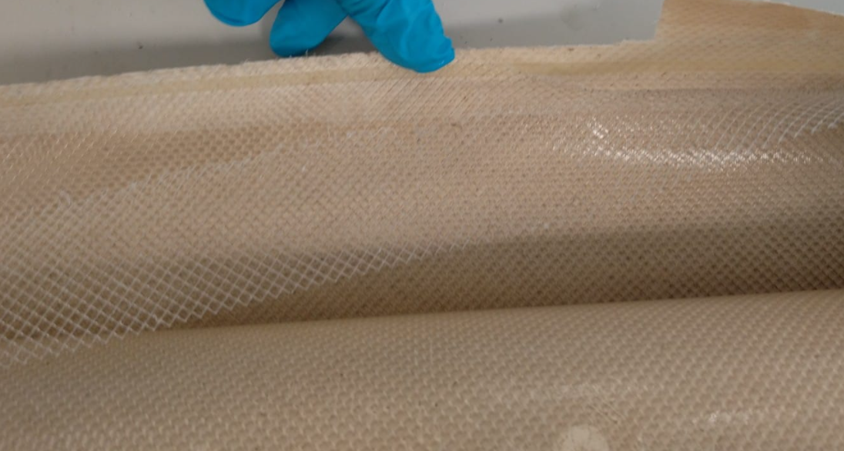

Figure 30 Fouling in the middle of the membrane envelope

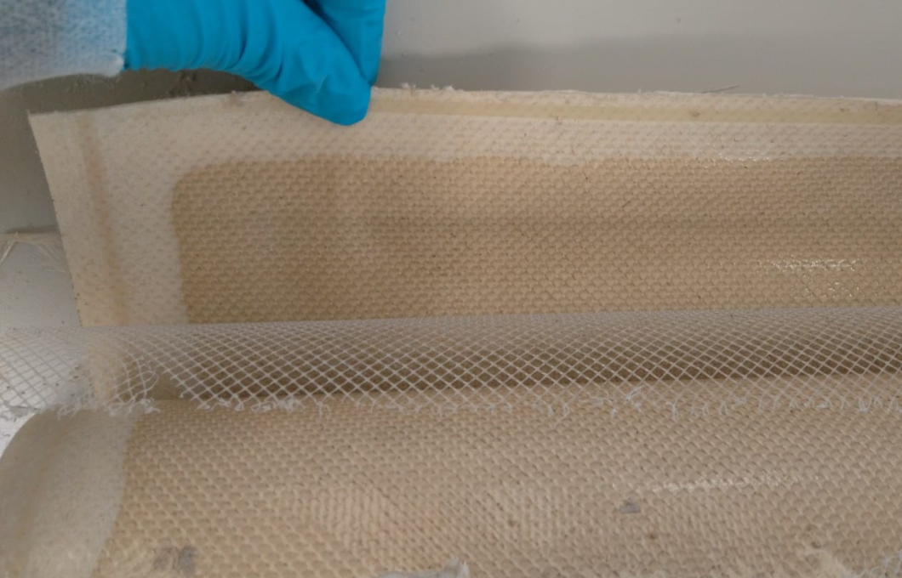

# A.2 Equations used in the RO normalization

$$SP={EC}_{p}×T_{cf_EC}×Q_{cf}$$

$${EC}_{p}=100×\frac{{EC}_{permeate}}{({EC}_{feed}×\left(log\frac{1}{1-Recovery}\right))/Recovery}$$

$$T_{cf}=\exp^{(U_{par}×\left(\left(\frac{1}{T_{feed}+273.15}\right)-\left(\frac{1}{T_{ref}+273.15}\right)\right))}$$

Where $U_{par}$ is the Dow membrane U-value, equal to 3200, ${EC}_{p}$ is the recovery corrected permeate conductivity, $T_{ref}$ is the reference temperature equal to 25 oC and is the conductivity corrected temperature.

$$NPD=dP×Q_{cf}×T_{cf}$$

$$dP=P_{feed}-P_{concentrate}$$

$$Q_{cf}={(\frac{Q_{vc}}{\frac{Q_{permeate}+Q_{concentrate}}{2}})}^{m}$$

$$Q_{vc}=\frac{Q_{feedn}+Q_{concentraten}}{2}$$

$$T_{cf}={(\frac{η_{ref}}{η_{feed}})}^{n}$$

Where NPD is normalized pressure drop [kPa], $Q_{feedn}$ normalized design feed flow of the RO system [m3.h-1], normalized design concentrate flow [m3.h-1], is the viscosity corrected temperature, $Q_{vc}$ is the viscosity corrected flow, $η_{ref }$ and $η_{feed}$ are reference and feed viscosity respectively, m and n are Dow membrane values, equal to 1.6 and 0.4, respectively.

$$MTC=\frac{Q_{permeate}×T_{cf}×{10}^{-5}}{36×Q_{pemeate}}$$

$$NDP=((\frac{P_{feed}+P_{concentrate}}{2}-P_{permeate})×100)-(\frac{{OP}_{feed}+{OP}_{concentrate}}{2}-{OP}_{permeate})$$

$$T_{cf_OP}=\frac{T_{feed}+273.15}{T_{ref}+273.15}$$

$${OP}_{feed}={EC}_{feed}×{EC}_{OP_feed}×T_{cf_OP}$$

$${OP}_{concentrate}={EC}_{concentrate}×{EC}_{OP_concentrate}×T_{cf_OP}$$

$${OP}_{permeate}={EC}_{permeate}×{EC}_{permeate}×T_{cf_OP}$$

Where MTC is the mass transfer coefficient [m.S-1.Pa-1], NDP net driving pressure [kPa], OP osmotic pressure calculated for feed, permeate and concentrate [kPa] and $T_{cf_OP}$ is the osmotic pressure corrected temperature.